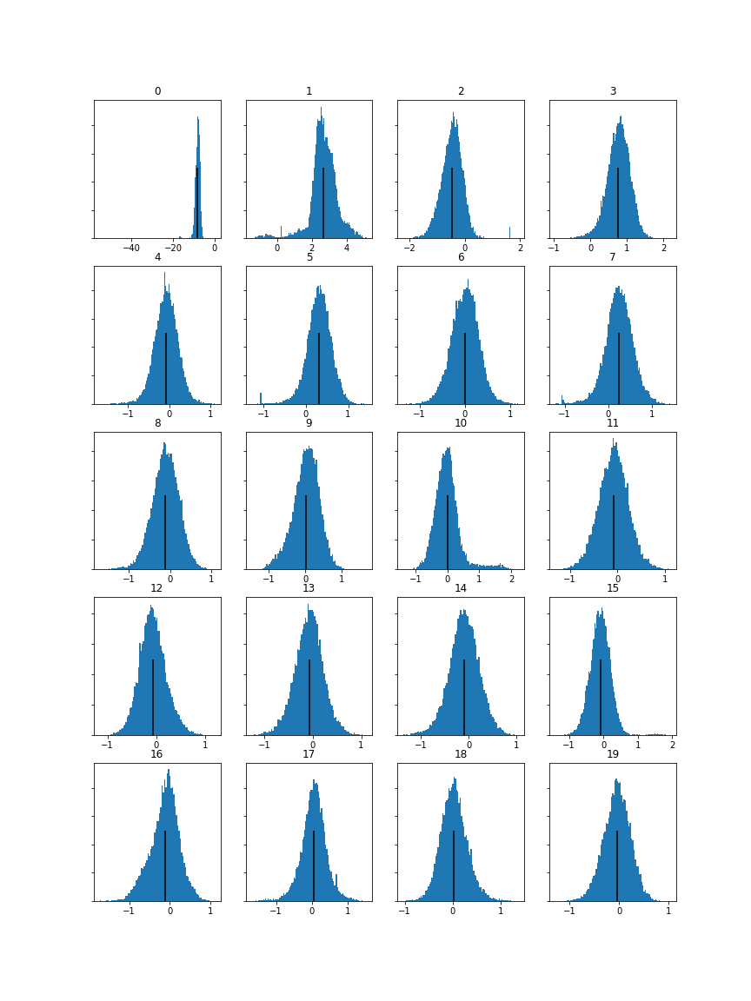Winter is Coming MFCC Histogram:

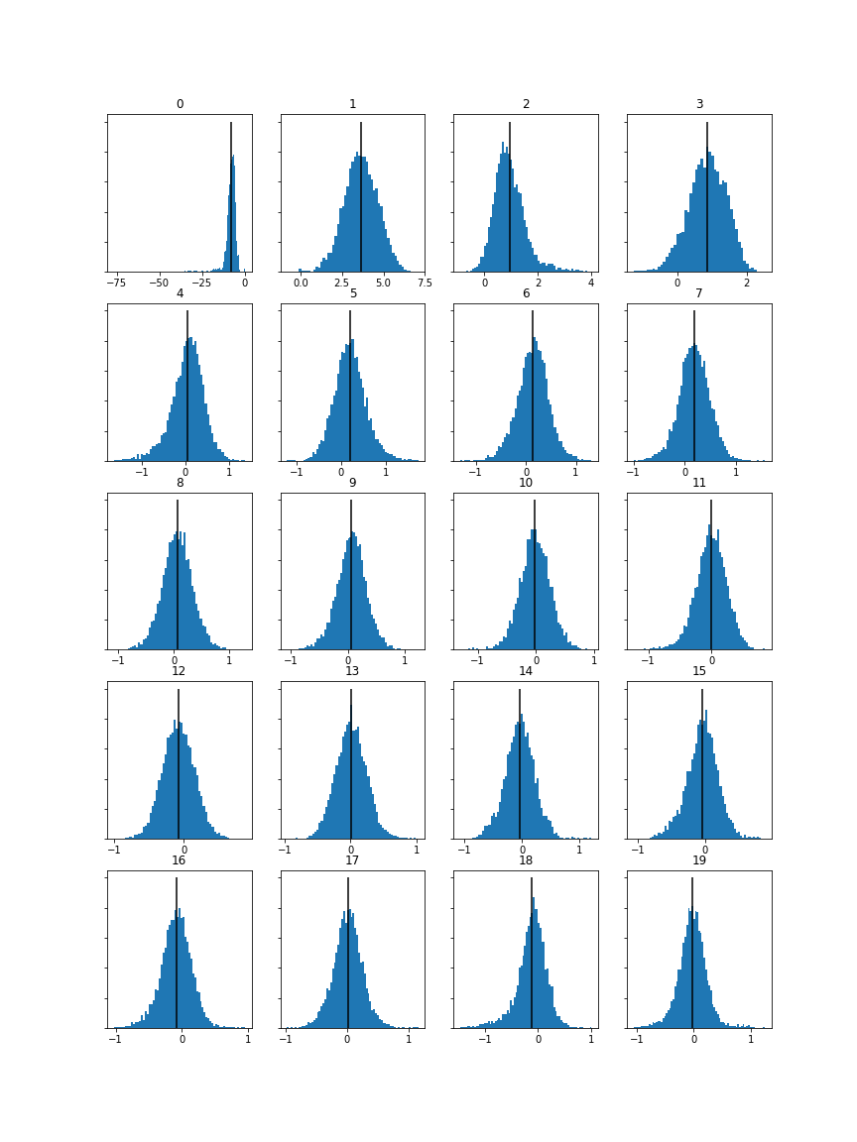Selfish MFCC Histogram:

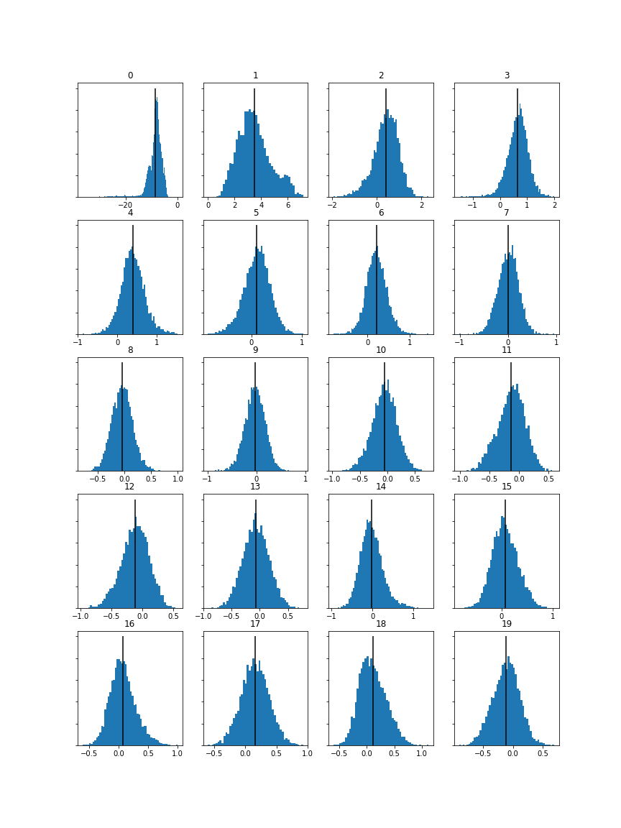Teamwork MFCC Histogram:

MFCCs show the difference in “timbre” for the music. By comparing the MFCC data for the 3 different tracks chosen, differences can be noted. One of the main differences is the scale: the 2 songs “Selfish” and “Teamwork” have a higher range on the y-axis compared to the piece of classical music “Winter is Coming”. This is to be expected, because when listening to the tracks, it is clear that “Winter is Coming” is a much softer piece of music compared to the 2 songs. The timbre of the instruments used is softer than in those 2. It is worth mentioning, however, that these MFCCs are not the most effective way to analyse music. As Beth Logan explains in her works titled “Mel Frequency Cepstral Coefficients for Music Modeling”, it is yet to be seen whether they are the optimal choice for modelling musical spectra.